TAW - Simple Weighing Series

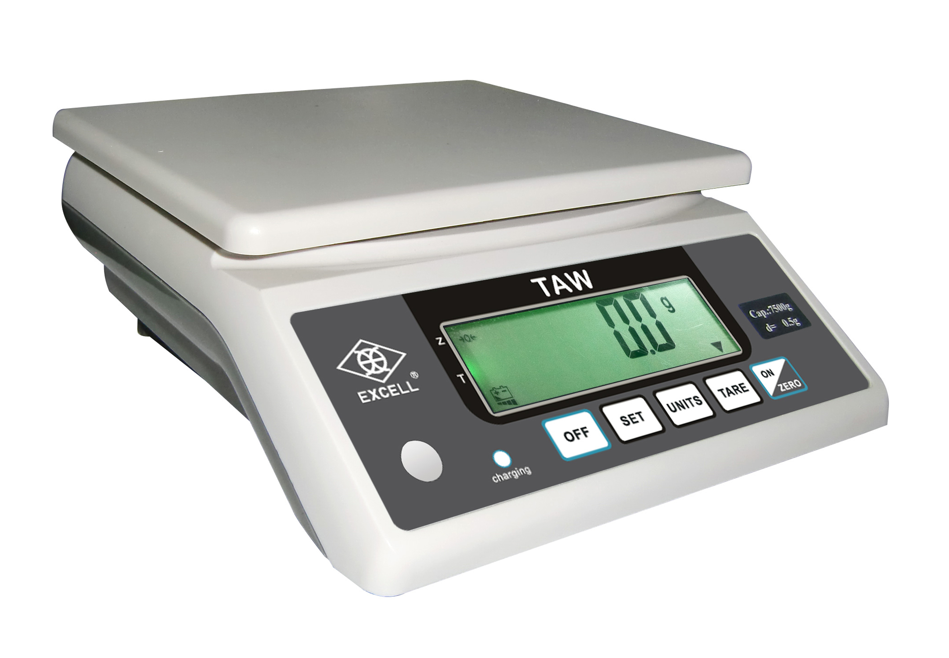
● FEATURES

- Various Functions: Fast and accurate weighing, simple counting, HI/LO/OK weight check, full-range tare.
- Unit switch key: Easily switch for kg, lb, and oz.
- Other considerate designs: Large LCD screen with backlight, auto power off, auto calibration, low battery alarm, dual overload protections, and light weight.
- AC/DC compatible: Power cord or batteries supported.
● SPECIFICATION
MODEL | CAPACITY | DIVISION | RESOLUTION
TAW-3 | 3kg | 0.2g | 1/15,000
TAW-7.5 | 7.5kg | 0.5g | 1/15,000
TAW-15 | 15kg | 1g | 1/15,000
Power supply: AC 110V/220V (±10%) + DC 6V/10AH rechargeable battery
Appearance: (WxDxH) 230 x 260 x 98 mm
Platter size: (WxD) 232x184mm (stainless steel platter optional)

